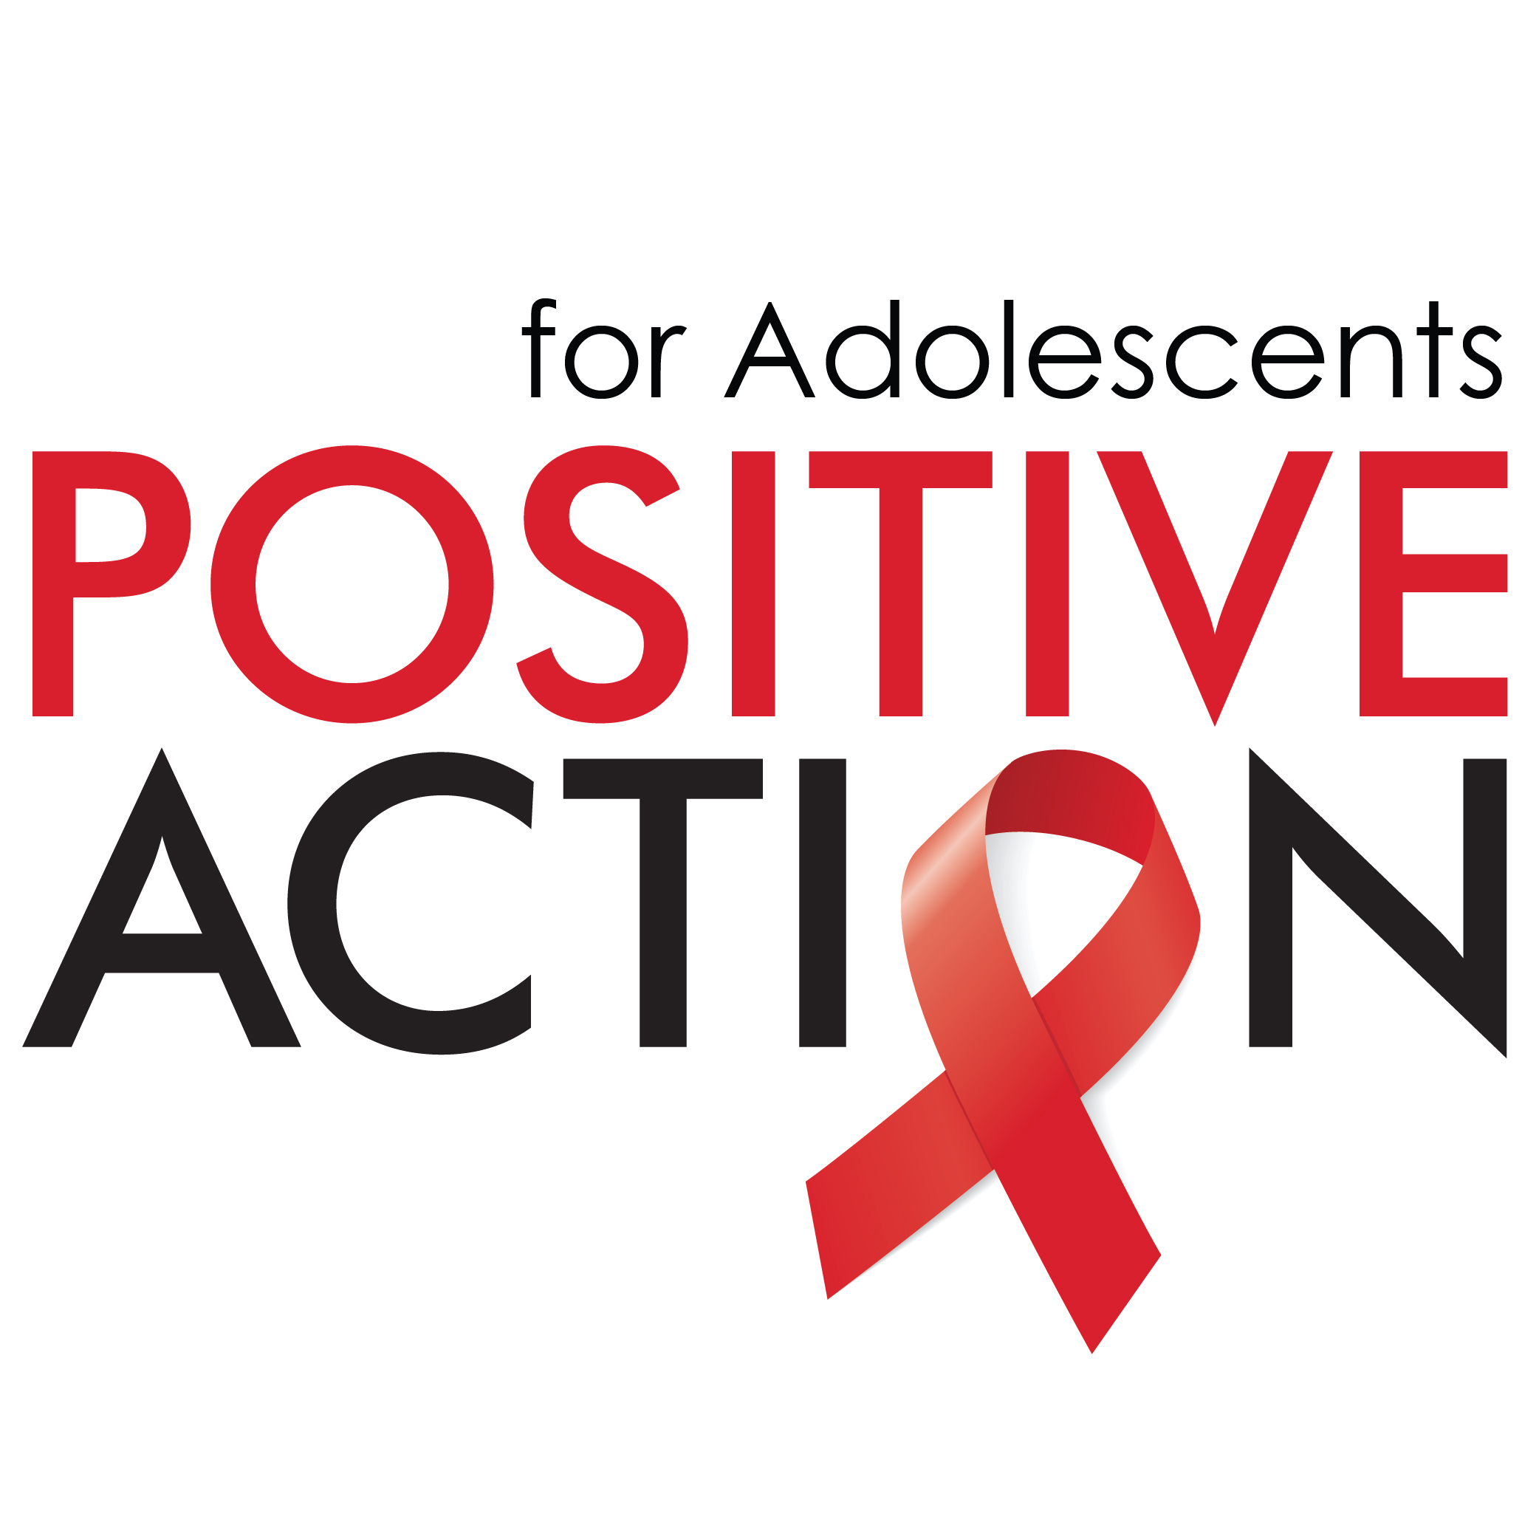
Positive Action for Adolescents
Youth-Led Grants Programme

Guidance Notes

Contents
Introduction 2
PAA Objectives 2
PAA Values 5
Eligibility 6
Size and Period of Grant 6
Organisation Type 6
Project Leadership 7
New Project 7
Geography 7
Budget 7
Language 8
How To Apply 8
Review Process 8
Monitoring and Evaluation 9
Frequently Asked Questions (FAQs) 10
Applications 10
Attachments 10
Collaborations 10
Budgets 11
Review Process 11
Miscellaneous 11

Introduction

Since 1992, Positive Action has been working with community-based organisations around the globe to support People Living with HIV, namely to tackle the stigma and discrimination faced by vulnerable populations affected by or infected with the HIV virus.

Positive Action for Adolescents (PAA) is a 5 year £10 million commitment established in 2015 by ViiV Healthcare to support and evaluate the impact of new behavioural and service delivery interventions that may address key gaps in adolescent HIV prevention, testing and care and enable improved service provision and treatment outcomes for adolescents through to adulthood. PAA also seeks to support capacity building, mobilisation and engagement of the adolescent community who can champion the needs of adolescents by ensuring that the realities of adolescents shape national responses to HIV/AIDS.

PAA’s strategic objectives were defined in consultation with global partners and community experts to ensure we focus our funding on programmes that can deliver solutions that address some of the outstanding needs of adolescents living with HIV. PAA’s efforts therefore align to Start Free, Stay Free, AIDS Free, the super-fast-track framework for ending AIDS in children, adolescents and young women by 2020, and the CIPHER/WHO Global Research Agenda for Adolescents Living With HIV which prioritises research themes in the areas of testing, treatment and service delivery for informing global policy change and improving outcomes for adolescents living with HIV.

PAA Objectives

Applications to the PAA Youth-Led Grants Programme should focus on improving adolescent health by targeting their proposal to the PAA Strategy.

Target Population(s)
- Ages 10-19
- Adolescent girls
- Young MSM
- Adolescents who are subject to sexual coercion and abuse
- Female and male sex workers
- Adolescents who inject drugs
Objectives
To support the creation and/or evaluation of the impact of new behavioural and/or service delivery interventions to address:

- Testing, linkage and retention in HIV care
- Transition to adult HIV care
- Onward disclosure of HIV status
- HIV prevention
In addition, in recognition of the integral role adolescents themselves play in driving better results for adolescents by leading efforts to encourage strategic changes in policy and improving health service provision, Positive Action for Adolescents is also focussed on
- Capacity building of adolescent community leaders (<30years of age)

More detail on each of these key areas is provided below:

- Improving service delivery to improve testing, linkage and retention of adolescents in care
Adolescents need more routine access to HIV testing and health services that effectively address the developmental, socio-political and other issues faced by young men and women. Testing venues need to be made more youth friendly and promising new approaches like self-testing need to be monitored as to how well they work for young people. Positive Action for Adolescent is interested in supporting projects/initiatives that evaluate the impact and effectiveness of different and novel service delivery interventions to improve testing, linkage and retention of adolescents in care. The role and sustainability of peer support, incentive programmes, SMS programmes and integration of HIV and sexual and reproductive health (SRH) in service delivery are all areas of interest for potential funding or partnerships. In addition, projects or initiatives that will enable the collection of higher quality data and research on adolescent outcomes that can ultimately be used to shape adolescent treatment policy/programmes and/or service delivery are also within scope. Data disaggregated by age and gender is urgently needed as is more research on adolescent-specific treatment concerns; including treatment failure, ‘loss to programme’ rates among adolescents living with HIV since birth, the number of adolescents requiring second and third line regimens as well as the incidence and impact of non-communicable diseases and disorders.

- Improving transition of adolescents to adult care/treatment programmes
The health and well-being of young people with chronic illnesses, particularly HIV/AIDS, hinges on uninterrupted and successful transition to adult care. Transitioning to adult care is associated with confrontation of the discrimination, and intra-/inter-personal complications associated with a communicable and socially stigmatized chronic infection. Without adequate preparation, the transition from paediatric to adult HIV care can therefore be compromised with potentially serious health consequences. Adolescents living with HIV need adult providers that can provide developmentally appropriate transition interventions that address loss, disclosure, and sexual behaviour along with medical needs. Positive Action for Adolescents is looking to support projects/programmes that are seeking to obtain data to better understand the reality of the issues faced by adolescents as they transition to adult care as well as to support the testing of new care packages/approaches that have been designed to improve the success of transition programmes.

- Supporting adolescents with onward disclosure of HIV status
It is well understood that disclosure of HIV status to others (e.g. a partner, family member or friend) is one of the key challenges for any HIV-positive person. Rates of onward disclosure in young people with HIV are low – particularly for perinatally infected adolescents. This appears to be driven by fear of negative responses from others, a lack of disclosure self-efficacy, a fear that the person they have disclosed to will tell others and parental attitudes towards onward disclosure (Evangeli & Foster, AIDS 2014; 28 (Suppl 3): S343-S346). However, onward disclosure potentially has a number of positive consequences in young people with HIV: 1) it may facilitate greater condom negotiation and use and reduce levels of unprotected sex and secondary HIV transmission; 2) it may facilitate improved adherence to antiretroviral therapy perhaps through disclosure-specific support or the reduced need to hide medication from others and 3) it may enhance well-being (this has been seen in other HIV-positive populations). Some psycho-social HIV disclosure interventions have recently been developed with the aim of increasing HIV disclosure rates. Promising outcomes have been seen in the populations they have been used in with reports of both increased disclosure and improved well being (Murphy D, et al J Consult Clin Psychol 2011; 79; 203-214; Serovich JM, et al. AIDS Behav 2011; 15: 1647-1653). Unfortunately no such interventions exist for young people with HIV (whatever the route of transmission). Positive Action for Adolescents is interested in supporting projects to develop and/or evaluate culturally sensitive, tailored and scalable disclosure interventions for young people with HIV as well as projects/initiatives that evaluate the consequences of onward disclosure during adolescence.

- Optimising prevention strategies and keeping negative adolescents negative
Around one seventh of all HIV infections are thought to take place in adolescence (UNICEF, Craig McClure quote, Press Release 2013). Therefore a better understanding of the role and balance of behavioural vs. biomedical interventions for prevention in this age group, as well as approaches that address social, economic and other structural factors that influence HIV prevention and transmission, are critical. Interventions or initiatives which utilise venues and activities where adolescents already gather (e.g. schools, after-school clubs, centres and community venues, virtual meeting places) to explore opportunities for youth-friendly prevention interventions are of interest. Proposed prevention interventions/initiatives should take into account the context in which the intervention is being delivered to thoughtfully address issues of stigma and discrimination.

- Building the capacity of adolescent community leaders
To end the epidemic in adolescents, investments and efforts need to be increased where they will make the most difference and this requires greater engagement and innovation by young people themselves as well as governments, international organisations, civil society and the private sector. Positive Action for Adolescents seeks to support capacity building, mobilisation and engagement of the adolescent community who can champion the needs of adolescents by ensuring that the realities of adolescents shape national responses to HIV/AIDS and to remove the structural barriers to access to health services by:
- Advocating for the review of laws that put age restrictions on the access of, or the requirement of parental consent for, sexual and reproductive health and HIV information and services
- Addressing the socioeconomic and policy contexts that increase HIV risk and vulnerability amongst adolescents (including stigma, discrimination and harmful gender norms).
Please note: trying to address all focus areas in your application will not improve the likelihood of success and in fact may weaken your submission.

PAA Values

Applications should ensure the methodology and approach taken to achieve their objectives is aligned to the following PAA values:

- Adolescent community involvement Adolescents should be actively engaged in the design, implementation, and monitoring & evaluation of projects/initiatives to ensure a relevant and acceptable adolescent-centred approach is taken. Not only will this improve what can be learnt from the projects/initiatives but it will also enhance the capacity and leadership skills of the adolescents involved – better equipping them to demand and support adolescent-friendly health services and programmes at the national and community level.

- Evidence based and evidence generating projects The Programme will support projects that are quantifiable and grounded in evidence or that commit to generating evidence. A robust monitoring and evaluation plan should be a part of each grant request – demonstrating how the project will address gaps in the current knowledge and understanding on the relevant key areas (described earlier in this document). Data demonstrating behavioural and/or health service delivery interventions that successfully increase testing, decrease infections and improve linkage and retention in care of HIV positive adolescents through to adulthood are of particular interest as this is a key goal in addressing adolescent HIV worldwide.

- Acceptable and scalable outcomes Potential grantees for the Positive Action for Adolescents Programme should explain in their proposals how the interventions or initiative for which they are seeking funding will ensure that they are acceptable to the end users prior to implementation. In addition, grant applicants should confirm that the interventions or initiative being evaluated has the potential to be implemented at scale if proven to be effective. This will help to ensure maximum benefit from Programme funding.

- Publication of results: We encourage grantees to publish the results and learnings from their work so as to raise awareness and share best practice amongst peers and programme managers more broadly.

- Use of online/mobile technology including social media: Internet-based interventions represent a different type of out-of-facility service. The rapid expansion of access to the internet and social media in the last two decades, even in low and middle income countries, through mobile phone technology, represents a significant opportunity to engage with previously hidden populations or those that are either socially or geographically isolated. There is increasing evidence of the acceptability of digital media-based interventions in adolescents globally although the impact on longer term health outcomes is yet to be determined. Online technology and innovation including social media should be carefully considered and leveraged when possible by grantees to inform, create demand and help monitor uptake, use and impact of services.

Eligibility

Before starting your application, please read the following section carefully to ensure that your organisation and proposal meet the PAA’s funding eligibility requirements. Applications that do not fulfil all of the following criteria will not be considered for funding.

Size and Period of Grant
Applicants may apply for funding of up to a total of £50,000 over a period of 1-2 years. Please note that all funding disbursements will be made in year 1.

Organisation Type
In order to be eligible for funding, applicants must be hosted by a non-governmental organisation (NGO). Organisations typically considered for funding include: Registered Charitable/Non-Profit Organisations, Community Based Organisations (CBOs), Non-Governmental Organisations (NGOs) and Social Enterprises.

Youth-Led
Projects must be youth-led by individuals between the ages of 18 – 24. Projects led by individuals between the ages of 25 – 30 will also be considered, but will need to demonstrate a robust involvement and engagement plan with the adolescent community as part of their proposal.

New Project
Your project must consist of new work that has not been previously funded. It may, however, include projects transferred to a new location(s) and/or include the expansion and/or evolution of a recently tested model or pilot. It may not be a continuation of a previously funded core activity/service in the same location.

Geography
Proposals focused on any geography will be considered. Please note that it is important that you must clearly demonstrate the need in the locale in which you are proposing your intervention. Applications from Sub-Saharan Africa and South Asia are particularly welcomed due to their alignment with the overall PAA programme strategy.

Budget
Your application must include a comprehensive budget accounting for all anticipated project spends, provided as an attachment.

This budget must adhere to the following criteria:
- 25% Rule: The total grant amount requested cannot account for more than 25% of your organisation’s annual income. Annual income is determined using your organisation’s previous budget year. For example, if your organisation had an income of £75,000 in your previous budget year, you would be eligible to apply for a maximum of £25,000 per year. Note that proposals from Low Income Countries, Lower Middle Income Countries, Least Developed Countries and Sub-Saharan African Countries are subject to a less strict 50% rule.

- 85% In Country: 85% of your project’s budget must be spent in the country(s) in which your project is focused and implemented.

- Maximum 15% Overheads: Overheads must account for no more than 15% of your total budget. Overheads are administrative expenses of your organisation that are required for its general operations and which cannot be definitively attributed to your project. Examples of overheads include, but are not limited to: rent, utility bills and printing costs. The salaries of individuals who are specifically employed to manage or support your project should not be included; however, any salaries of general administrative employees will count towards your 15%.

Please note that PAA does not ordinarily fund any large capital expenditures such as buildings, vehicles and testing machines except in exceptional circumstances. If large capital expenditure is justified and approved, it will count towards the 15% overhead allowed for projects.

We request that all budgets are submitted in Pound Sterling (£) (at the prevailing rate of exchange which should be stated).

Language
The PAA will consider applications submitted in English only.

How To Apply

All applications must be submitted to the PAA mailbox at: pa.adolescents@viivhealthcare.com

Applications must include:
- Completed Application Form
- Comprehensive Budget
- Organisation’s last set of audited accounts
The deadline for submitting your application is Friday 13th October.

Review Process

At the Internal Review stage your application may be rejected or shortlisted for the PAA Youth-Led Grants Board Review. All shortlisted applications will be reviewed by the PAA Youth-Led Grants Board in November 2017. You will be notified of the outcome of your application by December 2017.

Please note that all final awards approved by the Board are conditional, subject to any changes requested by the Board and successful completion of Positive Action’s due diligence validation process.

Monitoring and Evaluation

The PAA wishes to see that all funds dispersed will be clearly accounted for. If your application is successful, you will be expected to report on your progress through:

- quarterly phone calls (at minimum);
- six monthly written report providing a summary of programmes and activities, including data against your project indicators;
- annual financial report for the preceding year;

Successful applicants will receive detailed information on PAA’s monitoring and evaluation requirements prior to starting project implementation. Every grant we award is a partnership and we hope that if you are successful, we can work with, support and coach you to maximise the impact of your grant.

Frequently Asked Questions (FAQs)

Applications

What constitutes a strong project application?
A PAA project needs to be:
- New work, not the continuation of a previously funded activity
- Aligned to the PAA strategy and values
- Appropriate interventions aligned to identified needs in the area, showing clear understanding of community context
- Clear objectives and activities with achievable and measurable targets
- Achievable and measurable within the period of funding requested, including a measurable impact of the project on local community capacity to respond to adolescent HIV
- Incorporate adolescent engagement, participation and/or leadership
- Sustainable, replicable and scalable

Can we apply for part or co-funding?
Yes - provided the project is new and the other source of funding is named in the application, the PAA will consider applications for part-funding.

Where the PAA is being asked to co-fund, please make clear what specific aspect of the project you are requesting funds for.

Who should I designate as lead contact?
The PAA requests that the lead contact be the person responsible for delivery of the project at a country level wherever possible. We believe that building capacity includes managing grants and funders and therefore will require clear explanation when the proposed primary contact for a project is not in-country.

What is a ‘Beneficial Owner’?
A beneficial owner is an individual or group of individual who owns or controls directly or indirectly 25% or more of the organisation.

Attachments

My last financial years audited accounts are unavailable / I don’t have audited accounts / I have a project audit but not an organisational audit.
We require a set of audited accounts before funding will be disbursed. We will accept applications without audited accounts only if an explanation is provided with the reasons for non-submission and/or details of when audited accounts will be available.

Collaborations

Can we apply in a partnership or consortium?
Yes - we encourage collaborations with two or more organisations working together. Collaborative projects should ensure they address community needs and make sense programmatically with clear roles and responsibilities.

One organisation must act as the lead agency and will have to submit as the lead organisation on behalf of all partners, detailing both/all organisations details within your proposal. The lead organisation must also be prepared to hold the budget and take responsibility for the finances, management, delivery, communication and reporting of the project.

Budgets

What format must my comprehensive budget take?
The PAA application form provides a template for your budget.
Please provide all figures in GBP and group your costs into relevant headings. Please ensure you include all relevant costs including: salaries (local and international), programme costs, materials/supplies, monitoring and evaluation, travel, capital and overheads (i.e. office space, administrative costs, etc).

Will our financials be audited?
Yes - the PAA reserves the right to audit a project at any time. If sufficient evidence cannot be provided that funding is being used for the charitable purpose stated in your project proposal, we may terminate funding.

Review Process

How will my application be assessed?
Your Concept Note will be assessed for its adherence to the focus of the PAA project criteria outlined in the guidance, with particular importance placed on its relevance to the PAA strategy.

Who are the PAA Youth-Led Grants Board?
The PAA Youth-Led Grants Board Members are experts in the field of adolescent HIV. Board Members will be the subject of a future announcement.

Will I receive any specific feedback on my proposal?
No – due to the volume of applications submitted we unfortunately cannot provide individualised feedback.

Miscellaneous

Can we submit a proposal outside this process?
No – PAA is only accepted proposals during this PAA Youth-Led Grants Programme window.

What should I do if I have further questions?
Please contact the PAA mailbox pa.adolescents@viivhealthcare.com.

