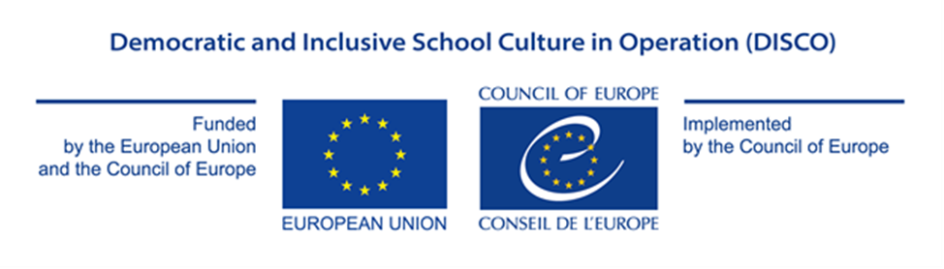

Appendix I

PROJECT PROPOSAL FORM

GRANT AWARD PROCEDURE

Democratic and Inclusive School Culture in Operation (DISCO)

EU/CoE Joint Programme for international co-operation projects

REF 2020/2021 DISCO

HOW TO COMPLETE THE PROJECT PROPOSAL FORM?

Complete each box with the information requested. The size of the box will adapt to the volume of text typed.

Once all fields are completed, print the Project Proposal Form, sign it, and send it in accordance with the requirements of the Call for Proposals.

PROPOSED ACTION

Please, describe clearly and distinctively under each section the role and relevance
of each applicant in the project implementation process

- Project overview: Please provide a description of the project:
Title ►
Overall aim ►
Outcomes (Specific Objectives) ►
Partner countries (NB: from 3 to 6, with at least half of the countries being a member of the EU) ►
Participating organisations/institutions in each country and their roles (ex. coordinator, participant, implementing agency) ►
Outputs (Expected results) ►
The Council of Europe Tool to be used (select only one of two options):► | Thematic priority 1: The implementation of the Council of Europe Reference Framework of Competences for Democratic Culture in education institutions ☐  OR  Thematic priority 2: Fostering democratic and inclusive culture in education institutions, with a particular focus on creating opportunities for migrants, refugees and minorities ☐

- Project concept and the description of activities (At least 1 page)

Please present the main ideas of your projects. Please describe the main project activities and indicate how they will lead to the foreseen outputs and outcomes of the project. ▼

- Appropriateness and relevance of the action in accordance with the Charter, the Council of Europe Framework of Competences for Democratic Culture and with the Paris Declaration

Please explain how the project will contribute to the implementation of the Council of Europe Charter on EDC/HRE, the Reference Framework of Competences for Democratic Culture and the provisions of the Paris Declaration. Please note in particular that the grants will fund projects designed to contribute to the sustainable development and promotion of education for democratic citizenship and human rights education. ▼

This programme cycle will focus on:

Thematic Priority 1: Competences for Democratic Culture in education institutions

Participating countries are invited to implement the Model of Competences, using the guidance provided in volume 3 of the Reference Framework of Competences for Democratic Culture. Information on the Framework is available at the following address: www.coe.int/competences.

Thematic Priority 2: Fostering democratic and inclusive culture in education institutions, with a particular focus on creating opportunities for migrants, refugees and minorities

The participating countries are invited to develop mechanisms to foster inclusion and a sense of belonging to a community for groups which face a high risk of exclusion, with a particular focus on migrants, refugees and minorities by creating opportunities to embed the learning environment in the local community based on a whole school/community approach.

- Potential impact on educational policy and practice in the participation countries

Please describe how the project will impact the educational policies and practices in the participating countries, including possible ways of evaluating such impact (1-2 years after the project), how will you ensure the sustainability of the action ▼

- Potential for awareness raising at national and/or international level
Please describe how the project will contribute to increased visibility and awareness of the role of citizenship and human rights education for the future of democratic societies and specify what visibility material is expected to be produced (ex. video and/or audio products, coverage on relevant websites, the use of social media, coverage in specialised magazines, other publications) ▼

- Implementation plan and co-operation between partners
Please present your implementation approach, indicating each partner’s role in the project. Please also describe the planning of activities and how you will ensure timely delivery of the main outputs. Please refer to the workplan under section I. ▼

- Human Rights Approach
Please indicate:
- how gender equality is relevant to your project and explain how men and women will be included in the project, and whether the project will affect men and women differently.
- what vulnerable groups can be identified in relation to the project? what factors potentially contribute to inequalities for these groups (power, status, resources)? and explain in what ways the project will include these groups and have an impact on them.▼

- Participation of the States party to the European Cultural Convention, which had not previously taken part in this Programme
Please indicate whether one or more of the following countries are among the partners for the present project proposal:
1. Azerbaijan 2. Denmark 3. Iceland 4. Kazakhstan 5. Liechtenstein 6. Luxembourg 7. Malta 8. Monaco 9. Netherlands 10. Portugal 11. San Marino 12. Slovenia 13. Switzerland ▼

 | - Workplan
 | Briefly present your plan for the implementation of activities until 31 October 2021 ▼
Activity |  | 2020 |  |  |  |  |  |  |  |  |  |  |  |  |  |  |  |  | 2021
Month |  | 3 | 4 |  | 5 |  | 6 |  | 7 |  | 8 |  | 9 |  | 10 | 11 |  | 12 | 1 |  | 2 |  | 3 |  | 4 |  | 5 |  | 6 |  | 7 |  | 8 |  | 9 | 10

SIGNATURE OF THE IMPLEMENTION PARTNER IN CHARGE
Name / First name of the Signatory ►
Title of position in the organisation of the implementing partner submitting the proposal ►
Place of signature ►
Date of signature ►
Signature and official stamp of the implementing partner submitting the proposal ►

